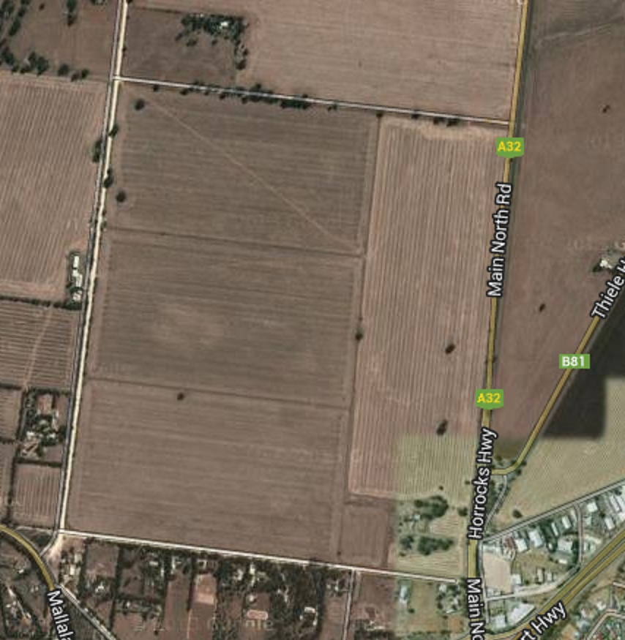
Future Paradise school (R-12 school).
Future Shopping centre complex.
Future Recreation centre/ community hall.
New released land.
Key
Carparking spaces Area of Settlers Paradise
Netball court Border of Settlers Paradise
Oval Shopping centre
Community buildings School
Road
Roundabout

- The boundary of land

